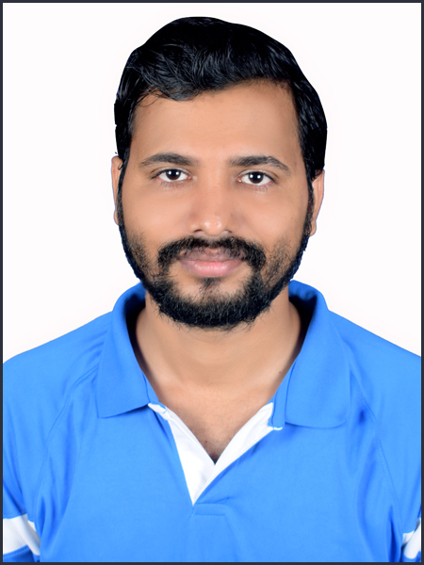**Faculty Profile Template**

1. **Basic Information**

* **Name**: RAJAN KUMAR SINGH
* **Designation**: Assistant Professor
* **Department/School**: Civil Engineering
* **Institution Name**: SSIPMT, Raipur
* **Email ID**: rajankumar.singh@ssipmt.com
* **Contact Number**: 9713445707
* **Photograph**:

1. **Educational Qualifications**

|  |  |  |  |
| --- | --- | --- | --- |
| **Degree** | **Specialization** | **Institution** | **Year of Completion** |
| UG | Civil Engineering | RITEE, Raipur | 2015 |
| PG | Structural Engineering | MMCT, Raipur | 2020 |
| Ph.D. | NA | | |
| Others | NA | | |

1. **Teaching & Research Experience**

* **Total Teaching Experience**: **10 Years**
* **Industry Experience**: ***NIL***
* **Research Experience**:**NIL**

1. **Courses Taught**

* **UG –** Introduction to Solid Mechanics, Introduction to Fluid Mechanics, Plane Surveying, Surveying & Geomatics, Structural Analysis-I, Structural Analysis-II, Structural Engineering Design-I, Structural Engineering Design-II, Structural Engineering Design-III, Estimation & Costing, Concrete Technology, Basic Civil Engineering & Mechanics, Hydraulics Engineering
* **PG-** Matrix Method of Structural Analysis, Finite Element Analysis of Structures, Structural Dynamics, Pre-Stressed Concrete

1. **Research Interests / Specialization**

* Concrete Technology, Structural Design

1. **Publications (Last 5 Years)**

* Journals (APA/IEEE format)

1. Ankita Kunjam, Rajan Kumar Singh, “Parametric Analysis of Geo polymer Concrete Containing Recycled Coarse and Fine Aggregates” Journal of Emerging Technologies and Innovative Research, ISSN-2349-5162
2. Utkarsh Sharma, Rajan Kumar Singh, “Performance Evaluation of Self-Curing, Self-Compacting Concrete Incorporating Sintered Fly Ash Lightweight Aggregate as a Partial Replacement for Coarse Aggregate” Journal of Emerging Technologies and Innovative Research

* Conference Proceedings-

ICRAMERD 2024, “Experimental Investigation of Plastic material as partial replacement of cement in concrete”

* Book Chapters / Books Authored- NIL

1. **Research Guidance**

|  |  |  |
| --- | --- | --- |
| **Level** | **Awarded** | **Ongoing** |
| Ph.D. | NA | NA |
| PG | 08 | 05 |

1. **Awards & Recognitions**

* Institutional / National / International- NIL

1. **Administrative Roles**

* Positions held (e.g., HoD, IQAC Coordinator, NAAC/NBA Committee Member)- NIL

1. **Professional Memberships**

* NIL

1. **Web Presence**

* Google Scholar-https://scholar.google.com/citations?hl=en&view_op=list_works&gmla=AH8HC4xoergc0dE3LPpnLDSTCVDuC6Ms3q3YgITJQnHc7xJWYQwdUoXyub7fTDnC4s43Jr_cTmwnl7gmOm-Vmw&user=Cj77cNEAAAAJ
* ORCID-

<https://orcid.org/> 0009-0005-9086-4455